00d- Sprint Information and Retrospective

Part One: Task Management Board
Team number: Group 12 |  | Sprint number: Sprint 2
Link to Scrum Board: https://trello.com/invite/b/69f1252414c3094e343d62fe/ATTI08c02146cbf06f985e835fed3d7d8b55340072F9/-

Sprint Goal: Add support for all languages and create report generation to complete all MVP requirements.
Tasks Planned: 49 | Tasks Completed: 48 |  |  |  | Tasks Carried Over: 1
"Sprint Done" column:

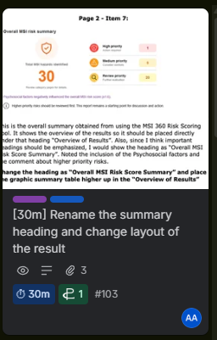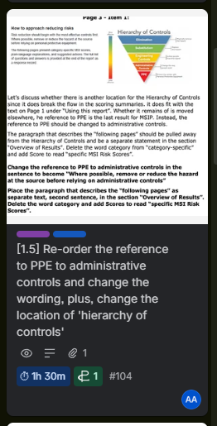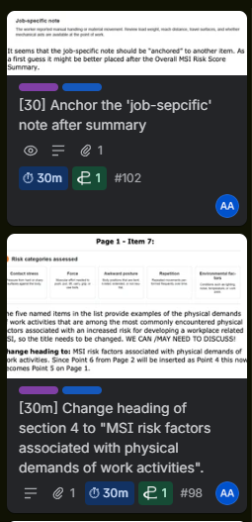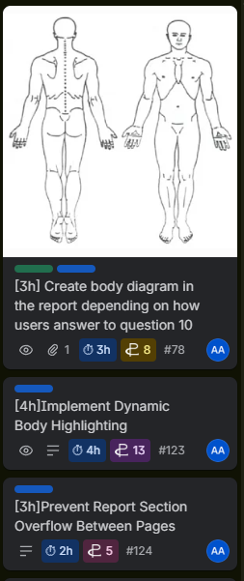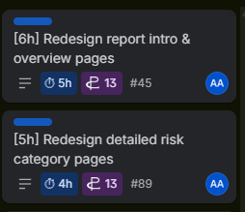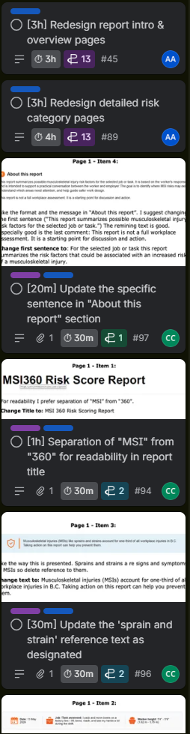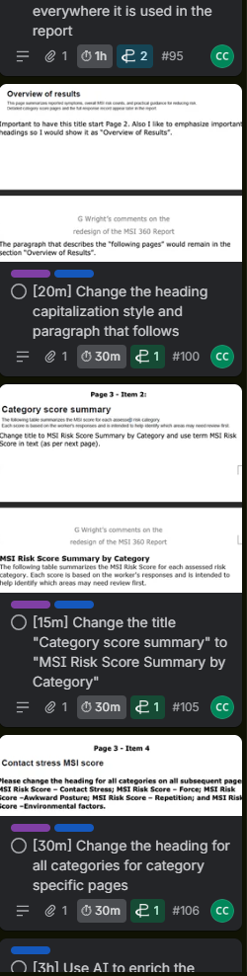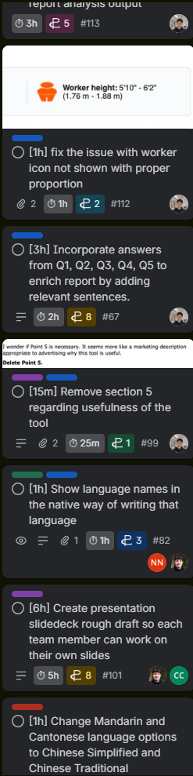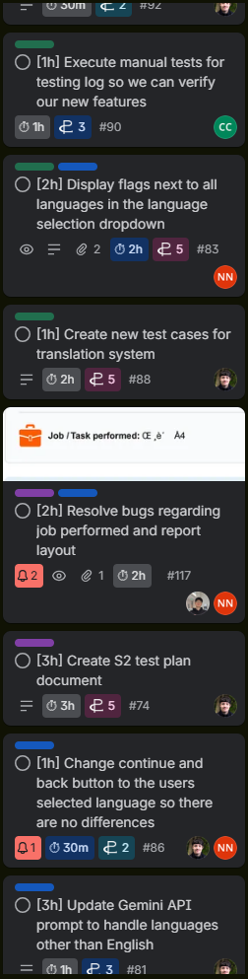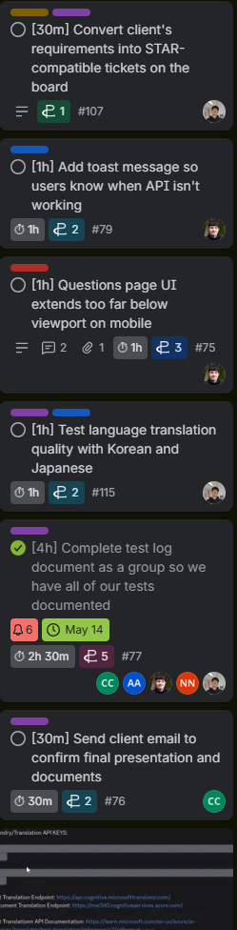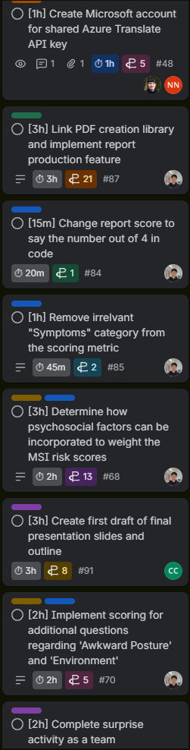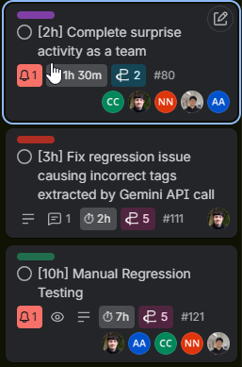

Part Two: Estimates and Actuals

Team Member | Estimated Work | Actual Work on Sprint | Variance (+/-) | Root Causes +  One-Sentence Explanation
Cole | 40h | 39h | -1h | - Filling in the test log didn’t take as long as I thought since we didn’t have that many tests for this sprints epics.
Nicholas | 40h | 38h | -2h | - I overestimated the time it would take to do the required manual regression tests as I thought it was a longer process and was doing more informal testing before and after versions were created.
Jonah | 40h | 36h | -4h | - My main task, the multilingual user text interpretation took much less time than anticipated.
Abdullah | 40h | 36h | -4h | - A few of the report layout tasks and manual testing took less time than expected
Kyle | 40h 30m | 42h | +1h30m | - Resolving conflict between multiple changes and refactoring existing layout took more time to figure it out
Total | 200h 30m | 191h | -9h 30m | - On average we overestimated a bit, with most of our overestimating coming from things related to testing and the test plan, we thought testing would take longer than it actually did.

Part Three: Retrospective

Individual:

1. What Went Well, appreciations, positive notes, etc
Name | Answer
Cole | Team chemistry continued to show and our meetings were very organized. We completed all epics we had planned.
Jonah | The client was quick to respond to our questions, and we were able to complete all main sprint objectives.
Abdullah | The dynamic body feature worked really well. It accurately highlights the areas where the user reported pain. The client was very happy with it
Nicholas | We managed to get translations done fully implementing AI and I am happy that it seems to have translated properly according to some user testing.
Kyle | We met most of the client’s requirements even though they were initially not plausible because of good prioritization and efficient work assignment.

2. What Could Be Improved, noteworthy, needs change, etc
Name | Answer
Cole | We could have a better system for reviewing PRs since a couple of them had merge conflicts.
Jonah | We could have spent more time documenting our code, to avoid time spent documenting before the hand-off in sprint 3.
Abdullah | I could improve by checking the final report pages more carefully before review, so small layout or wording issues can be caught earlier
Nicholas | I need to work on reading pull requests to ensure that I can resolve conflicts properly before merging them.
Kyle | We might need to come up with better way of testing locally so that we can merge without missing cases

3. Actions for Improvement, next steps, etc
Name | Answer
Cole | Since we don’t have any more full sprints we can’t take action on the PR issues in this project, but I will carry over these thoughts into my next project.
Jonah | We could implement a live hosted version of the app, so our client can get hands-on experience and provide feedback.
Abdullah | keep emailing the client for feedback instead of waiting for the next meeting, so we can fix issues earlier and move faster
Nicholas | I will make sure that the merged version of the app will work before fully merging them by reviewing some of the docs on GitHub.
Kyle | We will finalize our features and QA them so that we can focus on actual deliverable

Team:

5. Lessons Learned
- Our PR reviewing process could have been streamlined a bit to help prevent merge conflicts
- Frequent communication with client leads to a functional deliverable that everyone is happy with

6. Commitments for Next Time
- In our future projects, we will take more care when creating branches so that they are more independent and don’t rely on other changes.
- We’ll be able to provide a more accurate time estimate after confirming the core business requirements discussed in the initial meetings with clients earlier to prevent mission creep.

